Edward Lawrence Walters
December 5, 1926 – February 7, 1994

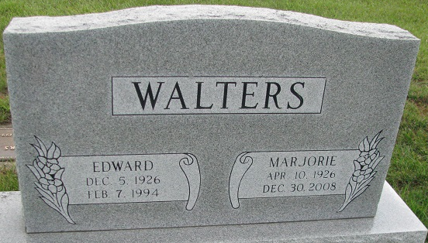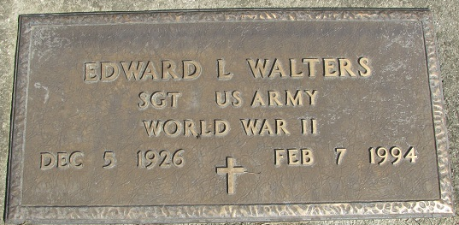
Photo by PLS

Edward L. Walters, 67, of Maben, Miss., died Monday in Webster General Hospital, Eupora, Miss. The former Decatur resident was president of Monte Glove Co.
Surviving is his wife, Marjorie; and sons, Randolph of Tyndall Air Force Base, Fla., Richard of Maben and Roland of Bristol, Wis.
Graveside services are 10 a.m. tomorrow in Decatur Cemetery. Calling is 6 to 8 p.m. today in Haggard & Armes Funeral Home, Decatur.

News-Sentinel, Allen County, Indiana
February 11, 1994

**
Edward L. Walters, 67, Maben, Mississippi, a former Decatur resident, died Monday in a Mississippi hospital. Among survivors are his wife, the former Marjorie Bieberich, who also once lived in Decatur, and three sons.
Graveside services will be at 10 a.m. Saturday in Decatur (cut off)

Decatur Daily Democrat, Adams County, Indiana
Thursday, February 10, 1994

**
U.S., Social Security Death Index, 1935-2014
Name: Edward L. Walters
Social Security Number: xxxx
Birth Date: 5 Dec 1926
Issue Year: Before 1951
Issue State: Indiana
Last Residence: 39750, Maben, Webster, Mississippi, USA
Death Date: 6 Feb 1994

