Edith Marie (Sunderland) Walters
August 13, 1913 – February 10, 2004

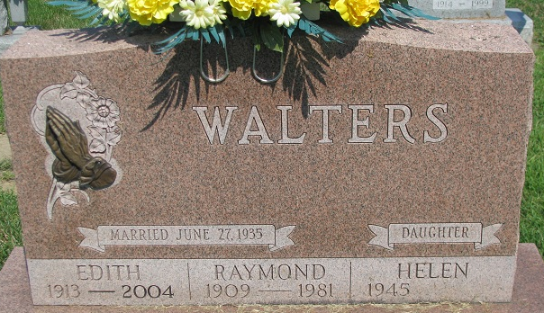
Photo by PLS

Mrs. Edith M. Walters, 90, passed away Tuesday at 8am at the Woodcrest Retirement Center, Decatur, IN. She was born on August 13, 1913 to William and Myrtle Sunderland in Sturgis, Michigan. She later married Raymond I. Walters; he preceeded Edith in death.
She worked at the worked at the Riverside Center (formerly the Decatur Parks and Recreation) for 25 years. There she helped prepare and serve dinner to many people including Ronald Reagan, John F. Kennedy and Robert Kennedy. She was a member of the First United Methodist Church where she held many church offices, the Pythian Sisters, the Women's Society of the Church and TOPS.
Mrs. Walters is survived by 3 daughters, Vera M. Petch, Decatur, Thelma J. Hinshaw, Anderson, IN and Helen M. Walters, Decatur, IN; 2 Grandchildren and 4 Great Grandchildren. Edith was preceeded in death by her husband Raymond I. Walters.
Visitation is 4-7pm Thursday, February 12, 2004 at Haggard and Sefton Funeral Home, Decatur, IN. Funeral Service is at 11am Friday in the Chapel at the First United Methodist Church, Decatur, with a 1 hour visitation prior to the service at the church.
All donations will be given to the church or to the Family Hospice of N.E. Indiana.

Decatur Daily Democrat, Adams County, Indiana
February 13, 2004

