Donna Jenett Walters
March 30, 1922 – March 30, 1922

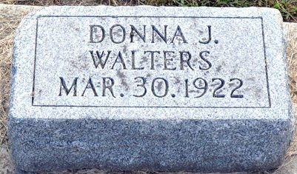
Photo by Deb Curry
Dohina Genett Walters
in the Indiana, Death Certificates, 1899-2011
Name: Dohina Genett Walters
Gender: Female
Race: White
Age: 0
Birth Date: 30 Mar 1922
Birth Place: Adams County
Death Date: 30 Mar 1922
Death Place: Decatur, Adams, Indiana, USA
Father: Lawrence Walters
Mother: Lena Ward
Burial: March 30, 1922 Decatur, Ind.

