Delbert Harrison Walters
October 16, 1870 – July 27, 1925

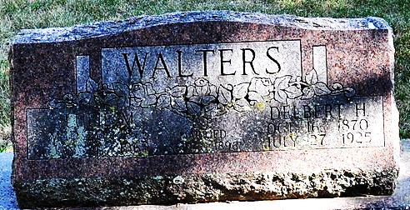
Photo by Deb Curry
ADAMS COUNTY FARMER DIES
Delbert H. Walters Succumbs to Leakage of Heart Monday Night

Delbert Harrison Walters, age 54 years, Adams County farmer, died at his home in St. Mary's Township, four and one-fourth miles east of Decatur at 8 o'clock Monday evening, following an extended illness of leakage of the heart. Mr. Walters had been ailing for the last six or seven years. Mr. Walters was a son of Henderson and Emily Walters and was born in St. Mary Township, November 16, 1870. He spent his entire life in St. Mary’s Township. He was a member of the Calvary Evangelical Church.
Surviving is the wife, Mrs. Lulie Walters, four sons, two daughters, three brothers, one sister and one half-brother. The children are: Chalmer, of Fort Wayne; Lawrence of near Decatur; Margaret, Raymond, Opal and John at home; one son, Chester is deceased. The brothers and sisters are: Oliver, Freeman and Amos, of Adams County; Mrs. Latisha Schnepp, of Adams County, Charles Walters of Cleveland, Ohio, is a half-brother.
Funeral services will be held from the home at 2 o'clock and from the Union Chapel Church at 2:30 o'clock Wednesday afternoon. Burial will be made in the Decatur Cemetery.

Decatur Daily Democrat, Adams County, Indiana
July 28, 1925

