Clement Lee Walters
January 10, 1869 – October 25, 1939

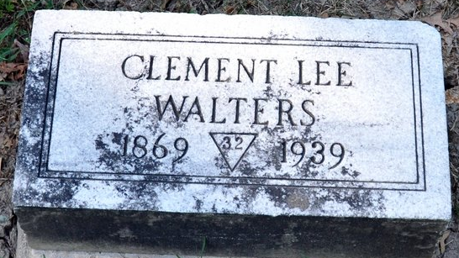
Photo by Deb Curry
C. L. Walters
in the Indiana, Death Certificates, 1899-2011
Name: C. L. Walters
Gender: Male
Race: White
Age: 70
Marital status: Married
Birth Date: 10 Jan 1869
Birth Place: Indiana
Death Date: 25 Oct 1939
Death Place: Decatur, Adams, Indiana, USA
Father: William Walters
Mother: Martha Drummond
Spouse: Grace McConnehey
Informant: Mrs. C. L. Walters; Decatur, Indiana
Burial: October 27, 1939; Decatur Cemetery
**
C. Lee Walters an able and prominent attorney of Adams County, although, still a young man has had a most active and varied business career since he passed from his youth to young manhood.
He was born January 10, 1869. His parents, William M. and Martha A. (Drummond) Walters, were long residents of Adams County. William Walters was a native of Pennsylvania and came to Adams County when a boy of thirteen. He was educated in the common schools of the county and began teaching school when still young. He gained much popularity as a teacher and after a few years was chosen county superintendent of schools. He served in this capacity from 1875 to 1879. In this latter year he removed to Clay County, Nebraska, where he resumed teaching. In a short time he was elected county treasurer of Clay County. He is a Democrat and has always been active in politics. He removed to Thomas County and was elected probate judge. After serving two terms he retired from active life.
Martha A. Walters, the wife of William Walters, is a daughter of Robert Drummond, a native of Ohio, and one of the pioneers of Adams County. Her father came to Indiana at an early date and settled on a farm in Root Township, where he became a prominent farmer and cultivated a large tract of land. He raised a large family and lived in Adams County until his death at his home in 1875. His sons settled in Adams County. The death of Mrs. Walters occurred in Ohio and she is survived by two children, C. L. Walters and a daughter, Alice, the wife of William Tuohy, who lives with her husband in Gladwin County, Michigan.
The boyhood of Clement Lee Walters was spent in Decatur. He was educated in the common schools of the county, completing the regular course. He attended the normal schools at Angola and Valparaiso and Blackburn University at Carlinville , Illinois . When he was twenty years of age he began teaching and taught continuously for eight years. He taught in all the grades of the common schools and was selected as assistant principal of the Decatur High School, in which city he taught five years in the grades and high school. In the intervals between his school duties he read law and passing the bar examinations, he was admitted to practice in the Adams County Courts.
Following the conclusion of his teaching period he engaged in the boot and shoe business. He continued in this business and in the general merchandise business until 1903, and then formed a partnership with Mr. John E. Kern to conduct a real estate business. This business was established in connection with a general mercantile business at Midland, Michigan, and it was in successful operation under the direction of these two men for three years. Mr. Walters then decided to take up his profession of law and to devote all of his attention to it. Accordingly he returned to Decatur and in September, 1906, he established his office. During the comparatively short time he has been engaged in practicing law he has built up a good practice and has gained much prominence. He is a man who, like his father, takes an active interest in politics. However, unlike his father, he is an adherent of the Republican Party. He is an active and able worker for his party and has received honor at the hands of his fellow Republicans. He has served as chairman of his party organization in Adams County and was appointed a deputy internal revenue collector for the northeastern district of Indiana. He held this office for a year and then resigned.
He has been selected a number of times to represent his party at county and state conventions, and has proved an efficient worker for his party's interests and an able and wise counselor. He is still actively engaged in politics, but in business devotes himself exclusively to the practice of his profession.
The marriage of Mr. Walters and Miss Grace E. McConnehey was solemnized in 1896. Three children have been born to these parents: Robert K., Helen and Dorothy. Mr. and Mrs. Walters are devout members of the Methodist Church and are among the most highly respected residents of their community. Both are educated people and their home is one of the most delightful in Decatur. Their social position in the community is exceptional and their home is the center of much of the social gayety of the city.
Mr. Walters is a thirty-second-degree Mason, being a member of the Bay City, Michigan, consistory; Elf Khurafeh Temple of the Mystic Shrine at Saginaw, Michigan. Both Mr. and Mrs. Walters are members of the Order of the Eastern Star.
Snow's History of Adams County, Indiana, John Fletcher Snow, B. F. Bowen, Indianapolis, IN, 1907, (image 611)

