Chester Lowell Walters
April 22, 1900 – February 15, 1923

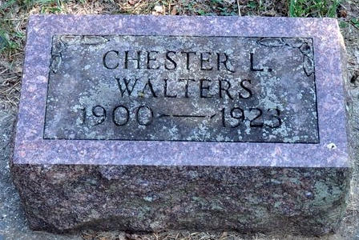
Photo by Deb Curry
LONG ILLNESS ENDED TODAY
Chester L. Walters, Age 22, Died at Home East of Decatur

Chester L. Walters, age 22 years, died at his home, five and one-half miles east of Decatur shortly before 4 o'clock this morning. Death resulted from tuberculosis and a complication of diseases.
Chester Walters, the son of Delbert and Lulie M. Walters, was born in St. Mary's Township, April 22, 1900. He was a well-liked young man and was possessed of a gentle disposition. About four years ago, while working at the Shafer Harness Shop in this city, where he worked for several years, he contracted tuberculosis. He was forced to quit work and since that time has lived with his parents on the farm.
A successful operation was performed after he contracted tuberculosis, which prolonged his life for three years. Three weeks ago the young man became worse and suffered a stroke of paralysis, which with bladder and lung trouble caused his death. He was a member of the Calvary Evangelical Church.
The parents, four brothers, two sisters, two aunts, and four uncles, besides a host of other relatives and friends, survive. The brothers and sisters are Lawrence R. Walters, of Decatur, and Chalmer L., Margaret E., Raymond I., Opal L., and John J., Walters, all at home.
Funeral services will be held from the Calvary Evangelical Church at 2 o'clock Sunday afternoon, with the Rev. Stedke, of Celina, officiating. The cortege will leave the house at 1:30 o'clock. Pall bearers will be Rollen Miller, Wayne Gaunt, Charles Barlett, Ivan Shifferly, Artie Jackson and Fred Barlett. Burial will be made in the Maple Wood Cemetery, of this city.

Decatur Daily Democrat, Adams County, Indiana
Thursday, February 15, 1923
**
Indiana, Death Certificates, 1899-2011
Name: Chester Lowell Walters
Gender: Male
Race: White
Age: 22
Marital status: Single
Birth Date: 22 Apr 1900
Birth Place: Saint Mary's twp., Ind
Death Date: 15 Feb 1923
Death Place: St Mary, Adams, Indiana, USA
Father: Delbert Walters
Mother: Lulie Smith
Informant: Lawrence Walters; Decatur, Indiana
Burial: February 18, 1923; Decatur Cemetery

