Chalmer L. Walters
August 10, 1897 – December 13, 1951

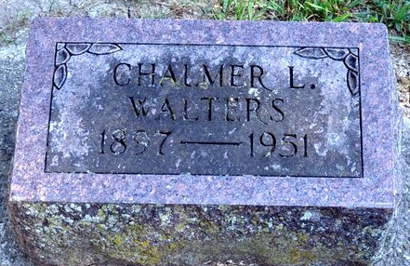
Photo by Deb Curry
Chalmer A Walters
in the Indiana, Death Certificates, 1899-2011
Name: Chalmer A Walters
Gender: Male
Race: White
Age: 54
Marital status: Widowed
Birth Date: 10 Aug 1897
Death Date: 13 Dec 1951
Death Place: Decatur, Adams, Indiana, USA
Father: Delbert Walters
Mother: Lulia Smith
Informant: Lawrence Walters; Decatur, Indiana
Burial: December 16, 1951; Decatur Cemetery; Decatur, Indiana

