Bryan Raymond Walters
October 4, 1952 – March 11, 1973

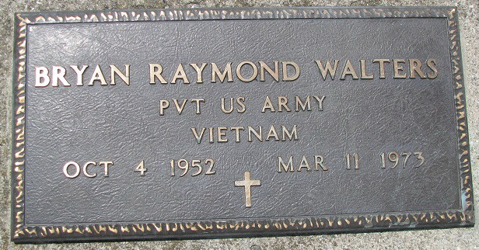
Photo by PLS
BRYAN R. WALTERS KILLED IN CALIF.
Bryan R. Walters, 20, of Burlingame, Calif., was killed Sunday evening in Calif., it was learned today. Mr. Walters was killed accidentally but no details were learned here. He was the son of Mr. and Mrs. John J. Walters of 410 Line Street. He was born in Quantico, Va., on Oct. 4, 1952, the son of John J. and Doreen Thomason-Walters, and was not married.
Surviving are his parents; one brother, Alan T. Walters, Burlingame, Calif.; one sister, Connie D. Walters, at home; his grandmother, Mrs. Annie Thomason, Sale, Cheshire, England; three uncles living in England; and one uncle and two aunts residing in Decatur. The body will be returned to Winteregg-Linn Funeral Home in Decatur. Funeral arrangements are incomplete.
Decatur Daily Democrat, Adams County, Indiana
March 16, 1973
**
RITES ARE SATURDAY FOR BRYAN WALTERS
Graveside funeral services will be held at 2 p.m. Saturday at the Decatur Cemetery for Bryan R. Walters, 20, of Burlingame, Calif., who was accidentally killed last Sunday. He was the son of Mr. and Mrs. John J. Walters of 410 Line Street. Rev. Cloyce C. Cunningham will officiate at the cemetery.

Decatur Daily Democrat, Adams County, Indiana
March 16, 1973

