Betty Joan Walters
December 2, 1929 – August 29, 2021

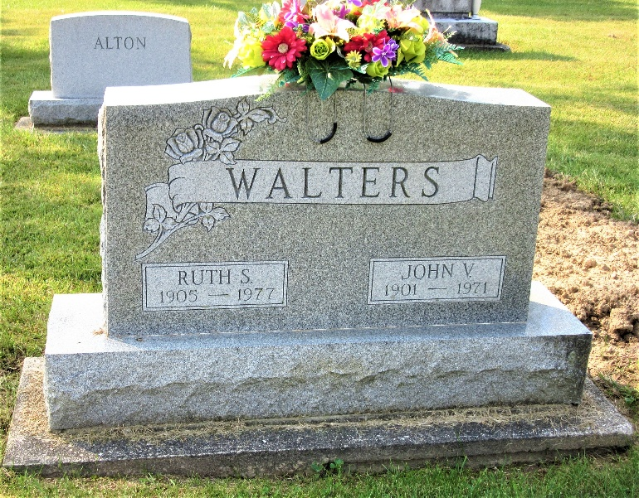
Photo by PLS
Betty Joan Walters, 91, of Berne, Indiana passed away Sunday evening, August 29, 2021, at Swiss Village. She was born on December 2, 1929 in Decatur, Indiana to John V. and Ruth S. (Martin) Walters.
Betty graduated from Decatur High School class of 1947. She was an active lifetime member of Union Chapel United Methodist Church, where she served on the Missionary Circle. She was a member of the Christian Women’s Club and the Adams County Historical Society.
She was employed by Northern Indiana Public Service Company from 1950 retiring in 1990.
She enjoyed traveling and studying the history of the United States. Betty was an avid genealogist, she had compiled a book for each of her cousins families and also all the doctors of Adams County.
She is survived by several cousins, Martin Lea (Lucile) White of Sunrise Beach, Missouri, Russell (Alice) Martin of Orlando, Florida, Steven Martin of Fort Wayne, Indiana, Michael (Diane) Martin of Cape Coral, Florida, Marlene (Jim) Nicely of Oak Field, Missouri, Melody (Doug) Tyler of Auburn, Indiana, Randall Martin of Auburn, Indiana, Ardola Burkhart of Monroe, Indiana, Ralph (Jocelyn) Parrish of Berne, Indiana, Arlene (Gary) Workinger of Monroe, Indiana, Charles Lynn of Huber Heights, Ohio, Barbara Miller of Harlan, Indiana, Sarah (Carlton) Ziegenfus of Allentown, Pennsylvania, Elbert (Karen) Schumm Jr. of Hamilton, Ohio, Barbara Schumm of Rockford, Ohio, Jane (Gary) Fisher of Rockford, Ohio, Dr. Herbert (Paula) Schumm of Loveland, Ohio, Cheryll Spirer of Murrysville, Pennsylvania, Dr. Neil (Jane) Martin of Florence Kentucky, Jennie Franz of Mansfield, Texas, and Jim (Sharon) Franz of Decatur, Indiana.
She was preceded in death by the Martin cousins, Mary Lou & Doyle Riney, David Martin, John Burkhart, Dorothy Lynn, Paul & Beverly Scheiderer, Gary Spirer, Robert Schumm, Dr. Jerry Franz, and Dianna Martin; and the Walters cousins, Leroy (Ruth) Walters and Marcella (Gerald) Springer.
Private family graveside services will be held at Decatur Cemetery.
Preferred memorials are to Union Chapel United Methodist Church.

Zwick & Jahn Funeral Home, Adams County, Indiana
August 31, 2021

