Barton P. Walters
April 26, 1882 – March 25, 1962

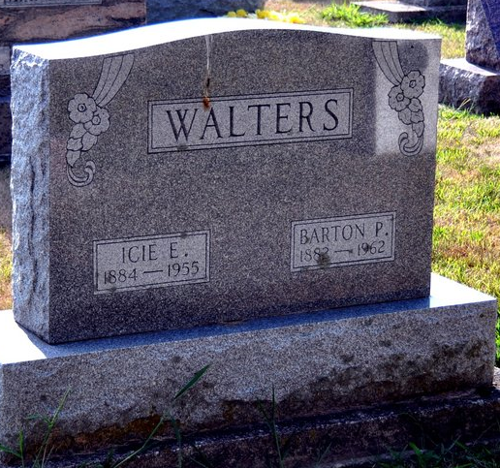
Photo by Deb Curry
Barton P Walters
in the Indiana, Death Certificates, 1899-2011
Name: Barton P Walters
Gender: Male
Race: White
Age: 79
Marital status: Widowed
Birth Date: 26 Apr 1882
Birth Place: West Virginia
Death Date: 25 Mar 1962
Death Place: Decatur, Adams, Indiana , USA
Father: Geroge Walters
Mother: Elizabeth Butcher
Informant: Mrs. Leo Workinger; daughter; Decatur, Indiana
Burial: March 28, 1962; Decatur Cemetery; Decatur, Indiana

