Amos C. Walters
December 9, 1874 – June 23, 1944

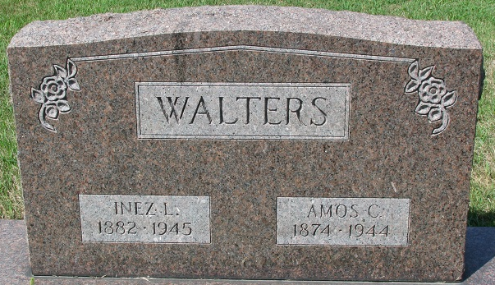
Photo by PLS
Amos Walters
in the Indiana, Death Certificates, 1899-2011
Name: Amos Walters
Gender: Male
Race: White
Age: 68
Marital status: Married
Birth Date: 9 Dec 1875 (sic)
Birth Place: Union Township, Adams Co
Death Date: 23 Jun 1944; shock from a fall
Death Place: Fort Wayne, Allen, Indiana, USA
Father: Henderson Walters
Mother: Emile Harrison
Spouse: Inez
Informant: Royce Walters; Fort Wayne, Indiana
Burial: June 26, 1944; Decatur Cemetery; Decatur, Indiana

