Elizabeth Othilda (Schneider) Walmsley
August 3, 1891 – October 13, 1980

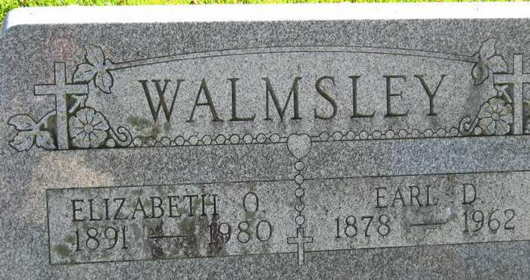
Photo by S. Riley
Elizabeth O. Walmsley
in the Indiana, Death Certificates, 1899-2011
Name: Elizabeth O. Walmsley
[Elizabeth O. Schneider]
Gender: Female
Race: White
Age: 89
Marital Status: Widowed
Birth Date: 3 Aug 1891
Birth Place: In.
Death Date: 13 Oct 1980
Death Place: Ft. Wayne, Allen, Indiana, USA
Father: Peter Schneider
Mother: Catherine Weber
Informant; Mary Gaffer of Decatur, Indiana
Burial: Oct. 16, 1980 St. Joseph's Cemetery (sic), Decatur, Ind.

