James R. Wall
March 20, 1898 – September 4, 1981

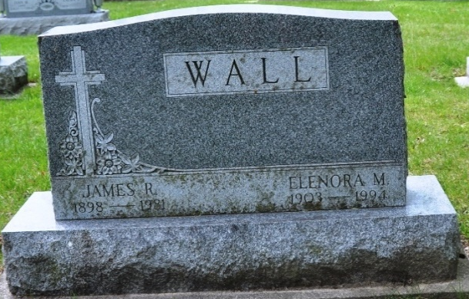
Photo by Deb Curry
James R. Wall
in the Indiana, Death Certificates, 1899-2011
Name: James R. Wall
Gender: Male
Race: White
Age: 83
Marital Status: Married
Birth Date: 20 Mar 1898
Birth Place: PA.
Death Date: 4 Sep 1981
Death Place: Decatur, Adams, Indiana, USA
Father: Stephen Wall
Mother: Margaret Egan
Spouse: Elenora Bleke Wall
Informant: Elenora Wall, wife
Burial; Sept. 8, 1981 Decatur Cem., Decatur, IN

