Emilie R. (Schultz) Wall
August 19, 1892 – February 19, 1987

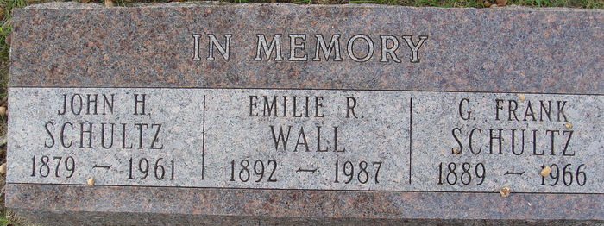
Photo by Alicia Kneuss
Emilie Wall
in the Indiana, Death Certificates, 1899-2011
Name: Emilie Wall
[Emilie Schultz]
Gender: Female
Race: White
Age: 94
Marital Status: Widowed
Birth Date: 19 Aug 1892
Birth Place: Indiana
Death Date: 19 Feb 1987
Death Place: Fort Wayne, Allen, Indiana, USA
Father: Henry Schultz
Mother: Christina Baker
Informant: Donald Helm, nephew
Burial: Feb. 23, 1887, Oak Hill Cem., Youngstown, Ohio

