Eleanora M. (Bleeke) Wall
September 3, 1903 – February 20, 1994

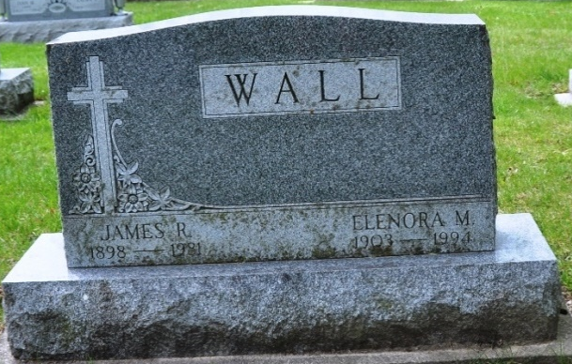
Photo by Deb Curry
Elenora M. Wall, 90, of Decatur died Sunday in Adams County Memorial Hospital. The Fort Wayne native was the widow of James R., who died in 1981. She was co-owner of Wall's Bakery from 1936-1967.
Surviving are a daughter, Gloria Nelson of Decatur, four grandchildren and three greatgrandchildren.
Services are 10 a.m. Thursday in Zion Lutheran Church, Decatur, with burial in Decatur Cemetery. Calling is 2 to 5 and 7 to 9 p.m. tomorrow in Zwick, Sefton & Jahn Funeral Home, Decatur. Preferred memorials are gifts to the church.

News-Sentinel, Allen County, Indiana
February 22, 1994

**
Indiana, Death Certificates, 1899-2011
Name: Elenora Wall
[Elenora Bleeke]
Gender: Female
Race: White
Age: 90
Marital Status: Widowed
Birth Date: 3 Sep 1903
Birth Place: Ft Wayne, Indiana
Death Date: 20 Feb 1994
Death Place: Decatur, Adams, Indiana, USA
Father: Fred Bleeke
Mother: Laura Mesing
Informant: Gloria Nelson, daughter
Burial: Feb. 24, 1994 Decatur Cem., Decatur, IN

