Harrison E. Walden
December 23, 1888 – May 18, 1971

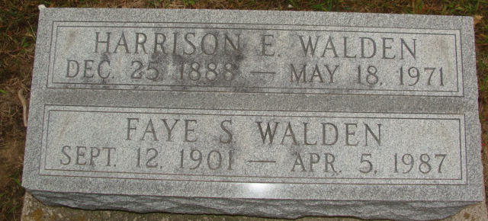
Photo by Alicia Kneuss
Harrison E Walden
in the Washington, Death Index, 1940-2017
Name: Harrison E Walden
Gender: Male
Residence Place: King, Washington, USA
Death Date: 18 May 1971
Death Place: King, Washington
Certificate Number: 011246
**
U.S., Social Security Death Index, 1935-2014

Name: Harrison Walden
Social Security Number: xxx
Birth Date: 23 Dec 1888
Issue year: Before 1951
Issue State: Michigan
Last Residence: 98031, Kent, King, Washington, USA
Death Date: May 1971

