Sarah Jane (Hughes) Wagoner
June 28, 1846 – March 3, 1917

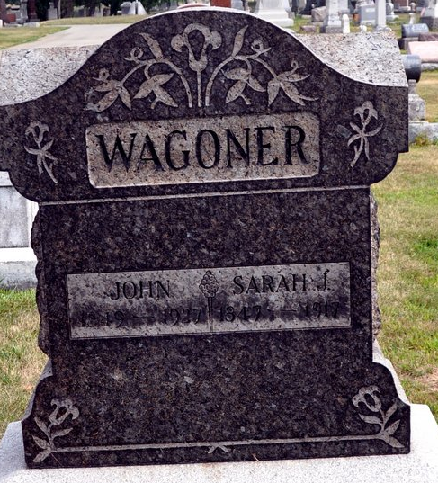
Photo by Deb Curry
DEATH ENDS ALL
Death of Mrs. John Wagoner of First Street Occurred Saturday Night
THE FUNERAL TODAY at Evangelical Church at 2 o’clock
Burial In Maplewood Cemetery

The death of Mrs. John Wagoner, residing on First Street, this city, occurred Saturday afternoon at 4:30 o'clock, after five years of suffering from paralysis. For that length of time she has been bedfast, the last year of her illness being especially acute.
She was a lifelong resident of this county, having resided on a farm south of the city until many years ago, when the family moved to Decatur.
Funeral services were held this afternoon at 2 o'clock from the Evangelical church, Rev. J. H. Rilling in charge, with burial in the Maplewood Cemetery.

Decatur Daily Democrat, Adams County, Indiana
Monday, March 5, 1917

**
Indiana, U.S., Death Certificates, 1899-2017

Name: Sarah Jane Wagoner
[Sarah Jane Hughes]
Gender: Female
Race: White
Age: 70
Marital Status: Married
Birth Date: 28 Jun 1846
Birth Place: Ohio
Death Date: 3 Mar 1917
Death Place: Decatur, Adams, Indiana, USA
Father: L D Hughes
Mother: Syntha Ann Eggworth
Spouse: John Wagoner
Buried: March 5, 1917; Decatur, Indiana

