Rowan Warren “Bill” Wagoner
February 21, 1910 – August 3, 1996

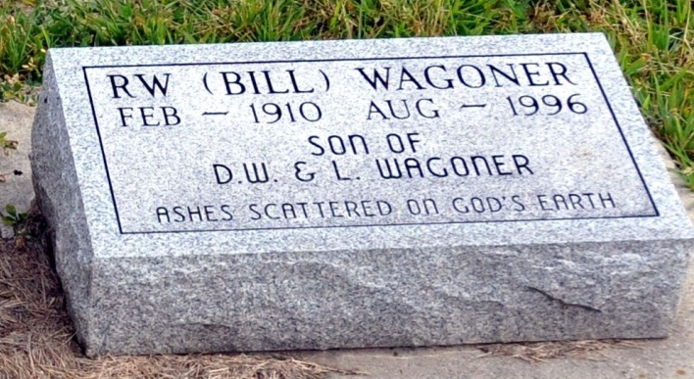
Photo by Deb Curry
Rowan Warren Wagoner
in the Florida Death Index, 1877-1998
Name: Rowan Warren Wagoner
Race: White
Age at Death: 86
Birth Date: 21 Feb 1910
Death Date: 3 Aug 1996
Death Place: Seminole, Florida, United States

