John Wagoner
March 15, 1849 – December 25, 1927

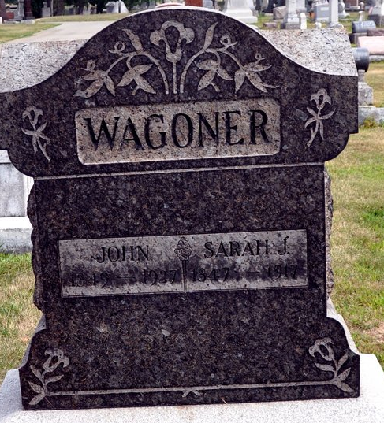
Photo by Deb Curry

John Wagoner
in the Indiana, Death Certificates, 1899-2011
Name: John Wagoner
Gender: Male
Race: White
Age: 78
Marital status: Married
Birth Date: 15 Mar 1849
Birth Place: Indiana
Death Date: 25 Dec 1927
Death Place: Decatur, Adams, Indiana, USA
Father: Nicholas Wagoner
Mother: Mary Everhart
Spouse: Ellen
Informant: Mrs. Ellen Wagoner, Decatur, Ind.
Burial: Dec. 28, 1927; Decatur Cem.

