Anna Sarah Jane “Annis” L. Wagoner
January 15, 1912 – May 14, 1913

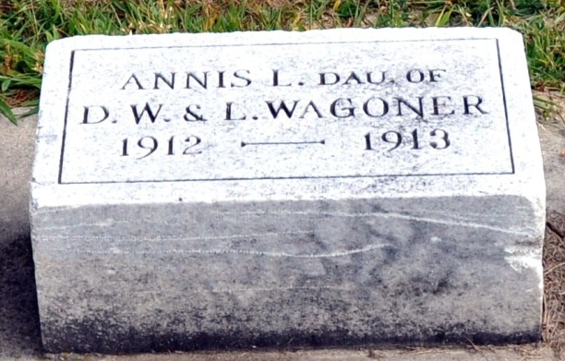
Photo by Deb Curry
WHOOPING COUGH
And Complications Prove Fatal to Sixteen-months-old Daughter of
DAVID WAGONER
Took Sudden Change for Worse Tuesday Evening -Funeral Saturday.
Whooping cough and complications arising therefrom, caused the death of little Anna Sarah Jane Wagoner, sixteen-months-old daughter of Mr. and Mrs. Dave Wagoner, residing on First Street, Wednesday evening at 4:30. The child had been suffering from the whooping cough for a week or so and was thought to have been improving as well as could be expected, when Tuesday evening she took a sudden change for the worse. A consultation of physicians was held and it was found that she was suffering from a complication of congested bowels. Her condition continued to become gradually worse until all hope of her recovery was abandoned and Wednesday evening at 4:30 her little soul passed to eternal rest and to Him (Who hath said: "Suffer little children to come unto me.”
Anna Sara Jane Wagoner was born Jan. 15, 1912, being at the time of her death one year and four months old.
The funeral services will be held Saturday afternoon at 2:30 from the Presbyterian Church in charge of Rev. Gleiser. Interment in the Maplewood Cemetery.
Decatur Daily Democrat; Adams County, Indiana
Thursday, May 15, 1913
**
Funeral services for little Annis Lusarar Wagoner were held Saturday afternoon at 2:30 o'clock at the home of her parents, Mr. and Mrs. David Wagoner, on First Street. The Rev. Gleiser of the Presbyterian Church officiated and the ceremony was a very beautiful one. The little one was laid to rest in Maplewood Cemetery.
Decatur Daily Democrat; Adams County, Indiana
May 19, 1913

