Lucille E. (Kelley) Wagner-Noll
July 26, 1918 – December 19, 1997

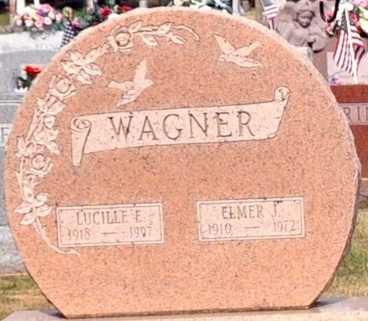
Photo by Deb Curry
Lucille E. “Petie” Wagner Noll, 79, Pleasant Mills, died at 3:25 p.m. Thursday in Adams County Memorial Hospital. She was born on July 26, 1918 in Allen County to William D. and Sylvia M. L. Beltz Kelley. She married Elmer J. Wagner on August 22, 1936; he died on August 14, 1972. She married Lowell B. Noll on December 14, 1986; he survives. She worked at Decatur Industries for seven and on-half years and was also a homemaker. She was a member of the Pleasant Mills Baptist Church, Veterans of Foreign Wars, Ladies of the Moose, and Eagles Lodge.
Other survivors include a daughter, Linda L. Jacobs, rural Decatur; two sons, Anthony L. Wagner, Decatur, and Kenneth W. Wagner, rural Decatur; three stepsons: John M. Noll, Decatur; Roger R. Noll, Fort Wayne; and Duane M. Noll, Ohio City, Ohio; four stepdaughters, Mrs. Jerry (Susan E.) Douglas, rural Decatur; Carol L. Coffield and Mrs. Kenneth (Marlene A.) Straub, both of Monroe; and Mrs. Marvin (Debra K.) Double, Pleasant Mills; three sisters, Luella A. Butler and Mrs. Ralph (Barbara J.) Busse, both of rural Decatur, and Velma K. Stevens, Monmouth; a brother, Richard L. Kelley, rural Decatur; eight grandchildren; 12 step-grandchildren; and two step-great grandchildren. A brother, Harold Kelley; a sister, Irene Loshe; a stepson and a stepdaughter are deceased.
Funeral services will be held at 10 a.m. Monday in Zwick-Sefton and Jahn Funeral Home, Decatur, with burial in Decatur Cemetery. Visiting hours are 3-8 p.m. Sunday, with a Moose memorial service there at 8 p.m. that day.

Decatur Daily Democrat, Adams County, Indiana
December 19, 1997

