Nicholas Henry Wagner
December 22, 1863 – September 23, 1919

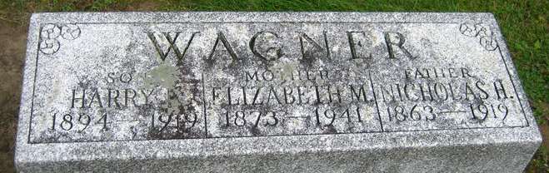
Photo by Sara Riley
MR. WAGNER DEAD
Well Known Man Succumbed at Midnight after Long Illness from Flu After-Effects; Was Fifty-five Years of Age; Funeral will be Friday Afternoon

Nicholas H. Wagner born and reared in Washington Township passed away last night at 12:30 o'clock at the home on N. Ninth Street following a long illness from after-effects of the influenza. He had been bedfast since Labor Day, and had rapidly declined since then. Mr. Wagner was fifty-five years old.
He was born December 22, 1863, in Washington Township, being a son of the late James Wagner. He was married March 15, 1891, to Miss Elizabeth Shank. They lived on various farms in this county, but prior to coming to this city a short time ago, had lived on their farm south of this city, near the county farm, selling the same when Mr. Wagner's health became impaired.
Surviving are the following children: Fred, of Washington Township; Harry, of Three Rivers, Mich.; Mary Starbuck, Fort Wayne; Rose Kitson, Fort Wayne; James, Wayne and Standford, at home. There are also the following sisters and brother living: Ella Estel, White County, Kas.; Mrs. James Middleton, Paragould, Ark.; Eve Diamond, Connecticut; Lynn Wagner, Grand Rapids, Mich.; Mary Andrews, Columbus, Ohio; Mrs. Lydia Martz, this city; Mrs. Angeline Peterseim, Portland.
The funeral will be Friday afternoon at two o'clock from the United Brethren Church, with burial in the Decatur Cemetery.

Decatur Daily Democrat, Adams County, Indiana
September 23, 1919

