Laura Marguerette (Anderson) Wagner
April 18, 1901 – October 8, 1933

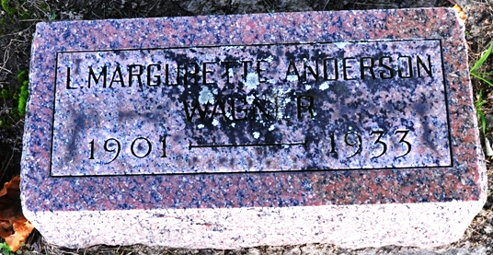
Photo by Deb Curry
Laura Margarett Wagner
in the Indiana, Death Certificates, 1899-2011
Name: Laura Margarett Wagner
Maiden Name: Anderson
Gender: Female
Race: White
Age: 32 years, 5 months, 20 days
Marital status: Married
Birth Date: 18 Apr 1933 [sic]
Birth Place: Ohio
Death Date: 8 Oct 1933
Death Place: Rockcreek, Wells, Indiana, USA
Father: James Anderson
Mother: Laura Wirick
Spouse: Wayne Wagner
Informant: none listed
Burial: October 10, 1933; Decatur Cemetery

