Jacob J. Wagner
July 18, 1889 – December 9, 1957

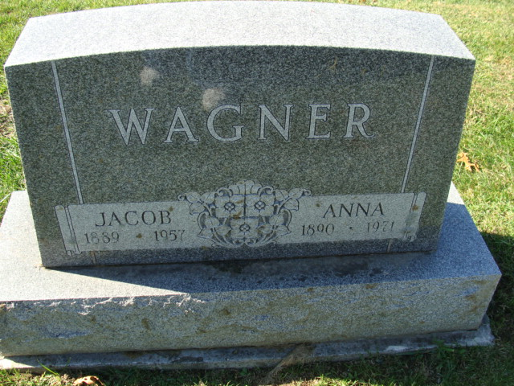
Photo by Alicia Kneuss
Heart Attack Fatal To Jacob J. Wagner
Root Twp. Farmer Dies This Morning

Jacob J. Wagner, 68-year-old retired farmer of Root Township, six miles northeast of Decatur, died suddenly of a heart attack at 11:30 o’clock this morning. He suffered the attack while at the Hugo Fueling Farm in Allen County, seven miles north of Decatur, where he worked occasionally. He had been ill for the past year but death was unexpected.
He was born in Bremen July 18, 1889, a son of Henry and Elizabeth Fox-Wagner, and was married to Anna Bucher Feb. 11, 1914. He had lived in Adams County for the past 50 years. He played independent baseball in this area for many years and was an ardent fan.
Mr. Wagner was a member of the Zion Lutheran Church in this city.
Surviving in addition to his wife are a son, Lloyd Wagner of Phoenix, Ariz.; one brother, William Wagner of Nappanee, and one sister, Mrs. Otis Troxell of Bourbon. Two brothers and three sisters are deceased.
Funeral services will be conducted at 1 p.m. Thursday at the Zwick Funeral Home and at 1:30 p.m. at the Zion Lutheran Church, the Rev. Edgar P. Schmidt officiating. Burial will be in the Decatur Cemetery. Friends may call at the funeral home after 7 p.m. Tuesday until time of the services.

Adams County Historical Museum, Adams County, Indiana
March 1955 - April 1958 Scrapbook, image 132
Handwritten date: Monday, December 9, 1957

**
Indiana, Death Certificates, 1899-2011

Name: Jacob J. Wagner
Gender: Male
Race: White
Age: 68
Marital status: Married
Birth Date: 18 Jul 1889
Birth Place: Indiana
Death Date: 9 Dec 1957
Death Place: Decatur, ?? Allen, Indiana, USA
Father: Henry Wagner
Mother: Elizabeth Fox
Informant: Mrs. Anna Wagner; wife; Decatur, Indiana
Burial: December 12, 1957; Decatur Cemetery; Decatur, Indiana

