Harry L. Wagner
January 16, 1894 – November 18, 1919

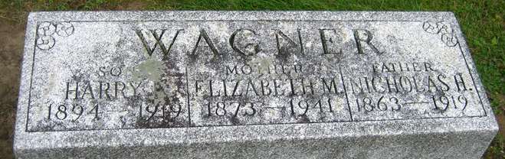
Photo by Sara Riley
FUNERAL OF HARRY WAGNER
DECATUR, Ind. Nov 19 – Funeral services for Harry L. Wagner, 25, will be held Thursday afternoon at 2 o'clock, from the United Brethren church, the Rev. C. J. Miner officiating. His death was due to infection that followed injury sustained last Sept. 9 at Three Rivers, Mich. His father, N. H. Wagner, died Sept. 23.
He is survived by the mother and following brothers and sisters: Fred, of Washington Township; Mary Starbuck and Rose Kitson, of Fort Wayne; James, Wayne and Stanford, at home.

News & Sentinel, Allen County, Indiana
November 19, 1919

