George V. Wagner
1920 – July 3, 1955

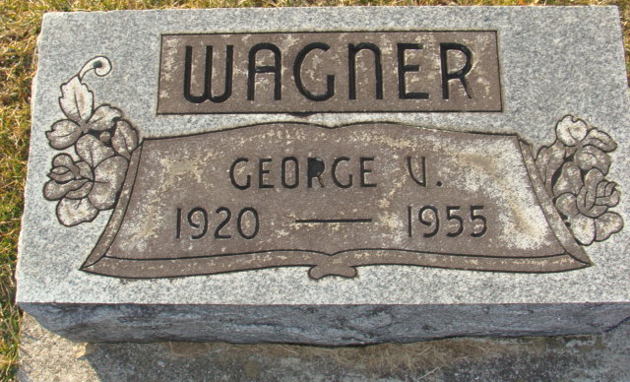
Photo by Alicia Kneuss
TWO KILLED WHEN CAR HITS BRIDGE ON U.S. HIGHWAY 127

DECATUR – Funeral arrangements have been announced for Bernard Eyanson, 31, and George Wagner, 34 of Decatur, Ind., who were killed Sunday when their auto crashed against a bridge seven miles north of Celina on U.S. Route 127.
Services for Wagner were held this afternoon at the Gillig & Doan Funeral Home and burial was in the Decatur Cemetery. Rites will be held at 9:30 a.m. Wednesday at the St. Mary's Catholic Church in Decatur for Eyanson. Burial will be in St. Joseph's Cemetery.
Eyanson was believed to have been driving the car when the crash occurred, since he was the owner. Three witnesses in a following car told investigating officers that the car had been weaving off and on the pavement before it hit the bridge. The southbound car hit the bridge with such force that part of the vehicle was thrown to the opposite side. The car was demolished. Both men were dead on arrival at the Gibbons Hospital in Celina. Dr. Donald Fox, acting Mercer County Coroner, filed accidental death findings.
Eyanson, native of Decatur and a World War Two veteran, was employed by the Pennsylvania Railroad. He is survived by his mother, Evangeline Eyanson, of Decatur; two sisters, Mrs. Martha Kirchenbauer of South Market Street, Van Wert, and Mrs. Mary Castle of Decatur; and four brothers, Robert, Theodore, Frederick and Raymond, all of the Decatur area.

Van Wert Times Bulletin, Van Wert County, Ohio
July 5, 1955

