Elmer J. Wagner
March 15, 1910 – August 14, 1972

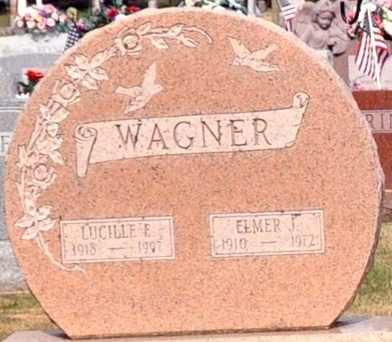
Photo by Deb Curry
Elmer J. Wagner Dies at Hospital

Elmer J. Wagner, 62, of the Oakhurst Trailer Court, Decatur Route 3, died at 9:30 p.m. Monday at the Adams County Memorial Hospital, where he had been a patient for the past two weeks. Mr. Wagner had been employed at the Central Soya Co. for 34 years. He was born in Allen County March 15, 1910, a son of Adolph and Emma Girardot Wagner and was married to Lucille Kelley Aug. 22, 1936.
Surviving are his wife, one daughter, Mrs. George (Linda) Jacobs of Decatur Route 6; two sons, Anthony I. Wagner of Decatur, and Kenneth W. Wagner of Monroe; his mother, Mrs. Emma Wagner of Monroeville; four sisters, Mrs. Flossie Daugherty of New Haven, Mrs. Robert (Grace) Crabil of Columbia City, Mrs. Luella Brown and Mrs. Gilbert (Mary) Baker, both of Monroeville; two brothers, Edgar and Clifford Wagner, both of Monroeville, and five grandchildren. Two brothers, Walter and Lloyd are deceased.
Funeral services will be conducted at 10:30 a.m. Thursday at the Zwick Funeral Home, with the Rt. Rev. Msgr. Simeon Schmitt officiating. Burial will be in the Decatur Cemetery. Friends may call at the funeral home after 7 p.m. today until time of the services. The rosary will be recited at 8 p.m. Wednesday.

Decatur Daily Democrat, Adams County, Indiana
August 15, 1972

