Elizabeth M. (Shank) Wagner
March 13, 1873 – September 29, 1941

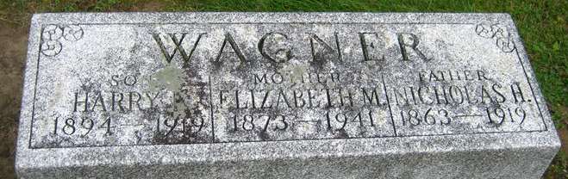
Photo by Sara Riley
DEATH CLAIMS MRS. WAGNER
Mrs. Elizabeth Wagner Dies Last Night after Long Illness

Mrs. Elizabeth M. Wagner, 68, widow of the late Nickolas H. Wagner, died at 11:50 o'clock last night at the home of her son, Fred E. Wagner, Decatur Route 4, after an extended illness of complications. She was born in Adams County March 13, 1873, the daughter of Frederick and Mary Shank. Her husband died about 20 years ago. Mrs. Wagner was a member of the St. Mary's Catholic Church.
Surviving are four sons: Fred of near Decatur, James H. and Stanford W. Wagner of Fort Wayne, and Wayne A. Wagner of Baltimore, Md.; one daughter, Mrs. Rose Irene Myers of Fort Wayne; one sister, Mrs. Martha Smith of Adams County; three half-sisters, Mrs. Anna Miller of Decatur, Mrs. Edward Marchand and Mrs. Sophia Dougherty, both of Fort Wayne, and six grandchildren. One son and one daughter are deceased.
Funeral services will be held at the church at 9 o'clock Thursday morning, Rev. J. J. Seimetz officiating. Burial will be in the Decatur Cemetery. The body may be viewed at the Gillig and Doan Funeral Home after 7 o'clock this evening until time for the services.

Decatur Daily Democrat, Adams County, Indiana
September 30, 1941

