Anna (Bucher) Wagner
May 16, 1890 – March 22, 1971

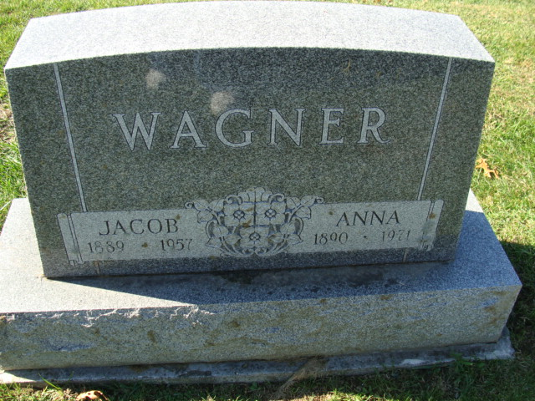
Photo by Alicia Kneuss
ANNA WAGNER TAKEN BY DEATH

Mrs. Anna Wagner, 80, a former resident of Decatur, died at 12:50 p.m. Monday at Swiss Village, located near Berne. Mrs. Wagner was a member of the Zion Lutheran Church.
She was born in Root Township, May 16, 1890, the daughter of Christ and Louise Knapp Bucher, and was married to Jacob J. Wagner on February 11, 1914. Her husband died on December 9, 1957.
Surviving are one son, Lloyd Wagner, Phoenix, Ariz., one sister, Mrs. Iva Franke, Hoagland, and one brother, Henry Bucher of Fort Wayne.
Funeral services will be conducted at 1:30 p.m. Thursday at the Zwick Funeral Home, with Rev. Paul Ludwig officiating. Burial will be in the Decatur Cemetery. Friends may call at Zwick Funeral Home after 2 p.m. Wednesday.

Decatur Daily Democrat, Adams County, Indiana
Tuesday, March 23, 1971
**

Indiana, Death Certificates, 1899-2011
Name: Anna Wagner
[Anna Bucher]
Gender: Female
Race: White
Age: 80
Marital status: Widowed
Birth Date: 16 May 1899 [sic]
Birth Place: Indiana
Death Date: 22 Mar 1971
Death Place: Berne, Adams, Indiana, USA
Father: Christ Bucher
Mother: Louise Knapp
Informant: Lloyd Wagner; son; Phoenix, Arizona
Burial: March 25, 1971; Decatur Cemetery; Decatur, Indiana

