L. E. Waggoner
March 15, 1851 – September 29, 1871

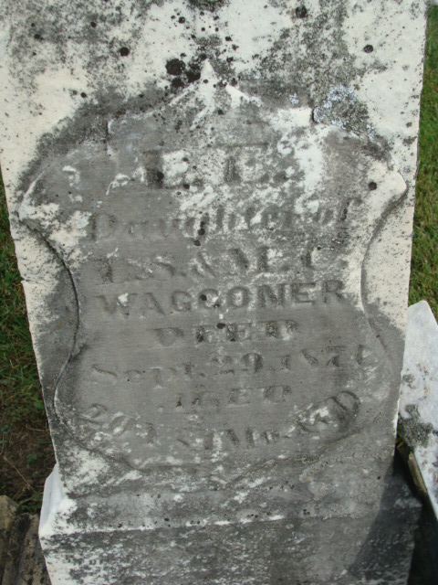
Photo by Alicia Kneuss
No further information found at this time

