Marion Glen Wable
April 14, 1918 – April 21, 1918

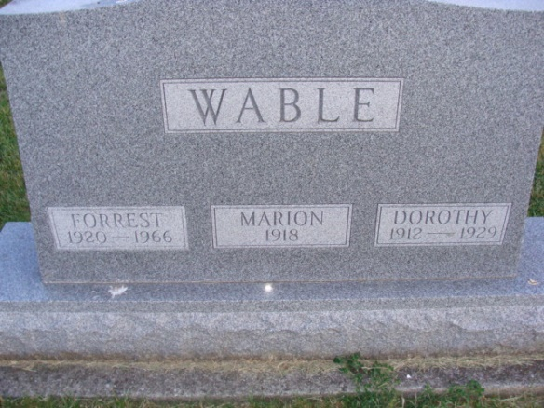
Photo by Alicia Kneuss
The 7 days old child of Mr. and Mrs. Jasper Wabel died, and the body was placed in the mausoleum at Willshire, O., following a short funeral service at the home.

Fort Wayne Sentinel, Allen County, Indiana
April 23, 1918

**
Indiana, Death Certificates, 1899-2011
Name: Marion Glen Wable
Gender: Male
Race: White
Age: 0
Marital Status: Single
Birth Date: 14 Apr 1918
Birth Place: Monroe Ft Adams Co
Death Date: 21 Apr 1918; premature birth
Death Place: Monroe, Adams, Indiana, USA
Father: Jasper Wable
Mother: Bertha Anderson
Burial: April 21, 1918; Wilshire Cem
Note: Also shows on his brother’s stone at Decatur Cemetery, Decatur, Indiana

