Jasper Leroy “Roy” Wable
February 10, 1905 – April 28, 1971

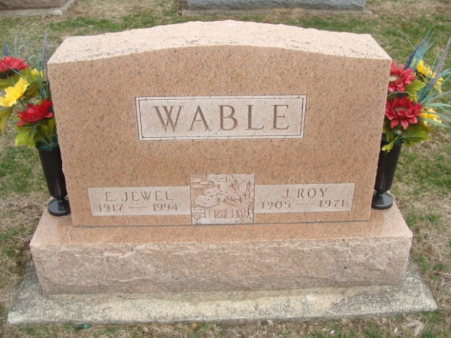
Photo by Alicia Kneuss
ROY WABLE DIES THIS MORNING

Roy Wable, 66, of route 6, a retired farmer, died at 9:45 a.m. this morning at the Adams County Memorial Hospital. He had been hospitalized for five weeks. He was a member of the Decatur Wesleyan Church.
He was born in Adams County on February 10, 1905, the son of Jasper and Bertha Anderson Wable, and was married to Jewell Birch on February 10, 1937.
Surviving are his wife; one son, Larry Wable, Fort Wayne; one daughter, Mrs. Jack (Carol) Butler, route 6; two sisters, Mrs. Arthur (Marie) Mitchel, Monroe; Mrs. Louis (Loretta) Mattax, Monroe; two brothers, Rollie Wable, Geneva; Alton Wable, route 1, Monroe; and four grandchildren. One brother, Forest Wable, preceded him in death.
Funeral services will be conducted at 2 p.m. Saturday at the Decatur Wesleyan Church, with Rev. Rex Tullis officiating. Burial will be in the Decatur Cemetery. Friends may call at the Zwick Funeral Home after 7 p.m. Thursday.

Decatur Daily Democrat, Adams County, Indiana
Wednesday, April 28, 1971
**
Indiana, Death Certificates, 1899-2011
Name: Jasper Le Roy Wable
Gender: Male
Race: White
Age: 66
Marital status: Married
Birth Date: 10 Feb 1905
Birth Place: Indiana
Death Date: 28 Apr 1971
Death Place: Decatur, Adams, Indiana, USA
Father: Jasper Wable
Mother: Bertha Anderson
Spouse: Jewell Birch
Informant: Mrs. Jewell Wable; wife; Decatur, Indiana
Burial: May 1, 1971; Decatur Cemetery; Decatur, Indiana

