Forrest Edwin Wable
December 2, 1920 – December 4, 1966

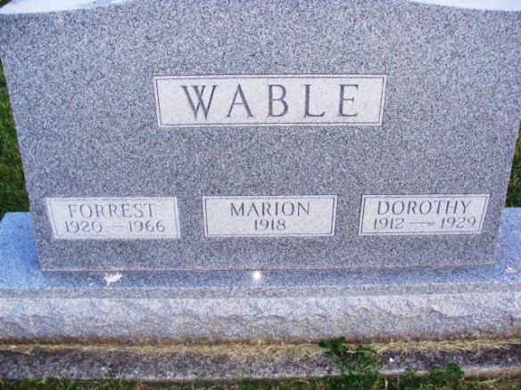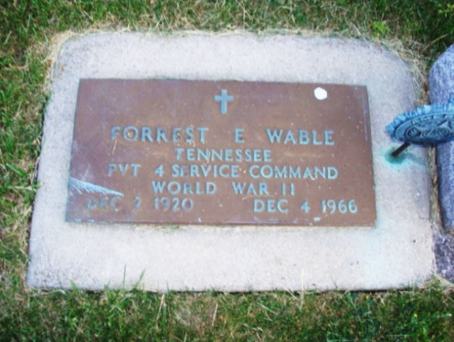
Photo by Alicia Kneuss
Forrest Edwin Wable
in the Indiana, Death Certificates, 1899-2011
Name: Forrest Edwin Wable
Gender: Male
Race: Caucasian (White)
Age: 46
Marital status: Never Married (Single)
Birth Date: 2 Dec 1920
Birth Place: Indiana
Death Date: 4 Dec 1966; suicide
Death Place: Berne, Adams, Indiana, USA
Father: Jasper Wable
Mother: Bertha Anderson
Informant: Roy Wable; brother; Decatur, Ind.
Burial: Dec. 7, 1966; Decatur Cem., Decatur, Ind.
**

U.S. WWII Draft Cards Young Men, 1940-1947
Name: Forrest Edwin Wable
Gender: Male
Race: White
Age: 21
Relationship to Draftee: Self (Head)
Birth Date: 2 Dec 1920
Birth Place: Adams, Indiana
Residence Place: Monroe Township, Adams, Indiana, USA
Registration Date: 16 Feb 1942
Registration Place: Indiana, USA
Employer: None
Weight: 145
Complexion: Light
Eye Color: Hazel
Hair Color: Black
Height: 5 9
Next of Kin: Jasper Wable
**

U.S., World War II Army Enlistment Records, 1938-1946
Name: Forrest E Wable
Birth Year: 1920
Race: White, citizen (White)
Nativity State or Country: Indiana
State of Residence: Indiana
County or City: Adams
Enlistment Date: 1 Jul 1942
Enlistment State: Ohio
Enlistment City: Toledo
Branch: Branch Immaterial - Warrant Officers, USA
Branch Code: Branch Immaterial - Warrant Officers, USA
Grade: Private
Grade Code: Private
Term of Enlistment: Enlistment for the duration of the War or other emergency, plus six months, subject to the discretion of the President or otherwise according to law
Component: Selectees (Enlisted Men)
Source: Civil Life
Education: 2 years of high school
Civil Occupation: Semiskilled millers, grain, glour, feed, etc.
Marital status: Single, without dependents
Height: 68
Weight: 131
**

U.S. WWII Hospital Admission Card Files, 1942-1954
Name: Forrest E Wable
Gender: Male
Race: White/Mexican (White)
Rank: Enlisted Man
Admission Age: 20
Birth Date: abt 1923
Birth Place: USA
Admission Date: Jan 1943
Admission Place: Camp Forrest, Tennessee
Discharge Date: Mar 1943
Military Branch: Infantry (or possibly Quartermaster)
Diagnosis: Diagnosis: Diabetes insipidus
Injured in Line of Duty: Not in Line of Duty, existed prior to entry into service
Type of Discharge: Disch for disability in LOD, Sec II [may also incl Disch for Disab (not LOD & existed prior to svc) or Cert of Disab Disch, Misconduct for part of Feb, March & Apr (1943) disp cases]
Length of service: 5 - 6 months
Service Number: 35330225

