Eva Jewel (Birch) Wable
September 21, 1917 – February 17, 1994

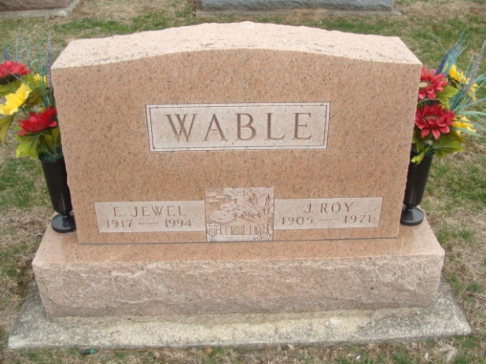
Photo by Alicia Kneuss
E. Jewel Wable, 76, of Decatur died yesterday in Adams County Memorial Hospital. She retired from the hospital's dietary department after 20 years and was the widow of Leroy, who died in 1971.
Surviving are a daughter, Carol Butler of Decatur; a son, Larry W. of Fort Wayne; sisters, Gladys Wiechman of Monticello, Dorothy Storde of Gilman, Ill., and Inez Fennig of Monroe; brothers, Harvey Birch and Russell Birch, both of Fort Wayne, and Kenneth Birch of Decatur; five grandchildren; and three great- grandchildren.
Services are 11 a.m. tomorrow in Haggard & Armes Funeral Home, Decatur, where calling is 2 to 5 and 7 to 9 p.m. today. Burial will be in Decatur Cemetery. Preferred memorials are gifts to Decatur Wesleyan Church.

News-Sentinel, Allen County, Indiana
February 18, 1994

**
Indiana, Death Certificates, 1899-2011
Name: E Jewel Wable
[E Jewel Birch]
Gender: Female
Race: White
Age: 76
Marital status: Widowed
Birth Date: 21 Sep 1917
Birth Place: Monroe County, KY
Death Date: 17 Feb 1994
Death Place: Decatur, Adams, Indiana, USA
Father: Sylvester Birch
Mother: Ethel Knuckles
Informant: Carol Butler; daughter; Decatur, Ind.

