Dorothy Wable
August 4, 1912 – February 11, 1929

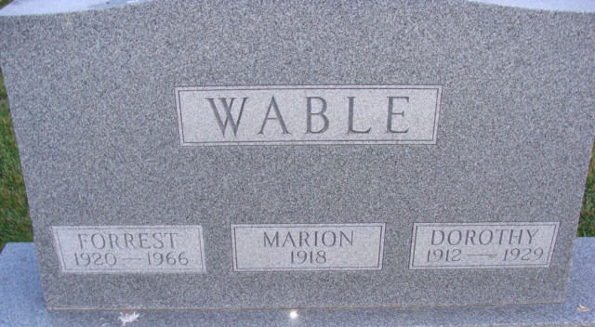
Photo by Alicia Kneuss
Dorothy Wable
in the Indiana, Death Certificates, 1899-2011
Name: Dorothy Wable
Gender: Female
Race: White
Age: 16
Marital Status: Single
Birth Date: 4 Aug 1912
Birth Place: Adams Co. Indiana
Death Date: 11 Feb 1929; influenza
Death Place: Monroe, Adams, Indiana, USA
Father: Jasper Wable
Mother: Bertha Anderson
Spouse: Not Married Wable
Informant: Jasper Wable
Burial: Feb. 14, 1929 Willshire Cem.

