Lulu Mae (Sanquist) Voshell
May 10, 1918 – January 12, 2009

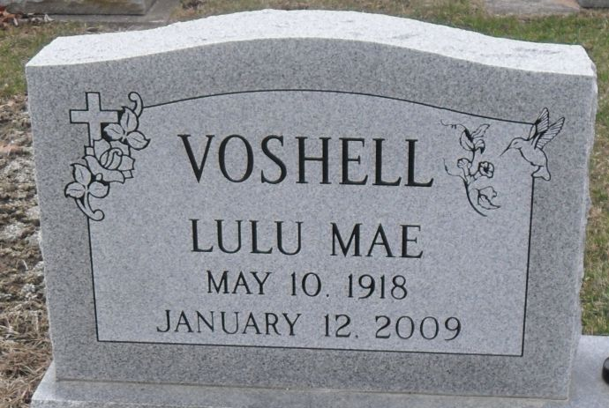
Photo by Stephen & Andrea Brangan

LuLu Mae Voshell, 90, of Berne, Indiana passed away January 12, 2009 at Swiss Village Retirement Center in Berne. She was born on May 10, 1918 in Sebeka, MN to the late Spencer and Olive (Goble) Sanquist.
She is survived by a son Bruce (Karen) Voshell of Decatur; two daughters Mrs. Janice (Luther) Schrock of Forest Grove, Oregon, Mrs. Sharon Fleck of Bloomington, Ill.; two brothers Melvin Sanquist, Spencer Sanquist; two sisters Lorraine Wahls of Paducah, KY, Imogene Pennington of Murphysboro, Ill; seven grandchildren and seven great grandchildren. She is preceded in death by a brother Lloyd Sanquist and a granddaughter Debra Schrock. LuLu was a member of First United Methodist Church and a former member of Wesley Sunday School class, Historical Society, ONO Extension Club, Civic Club and Beta Sigma Phi. She worked as a telephone operator for Citizens Telephone Co. in Decatur.
Visitation will be from 6-8 pm Thursday, January 15, 2009 at Haggard & Sefton Funeral Home and from 1-3 pm Friday, January 16, 2009 at Swiss Village in Berne. Funeral service will be at 3:00 pm on Friday at Swiss Village. Rev. Loren Felabom will be officiating. Interment will follow at Decatur Cemetery.
Memorials are to Family Hospice & Palliative Care of Northeast Indiana, First United Methodist Church or Swiss Village.

Decatur Daily Democrat, Adams County, Indiana
January 14, 2009

