William Lee Voirol
February 2, 1959 – July 31, 1982

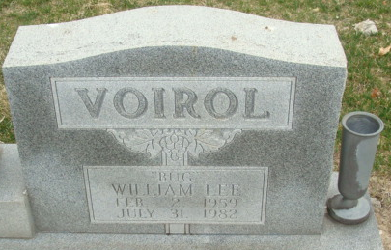
Photo by Alicia Kneuss

William Lee Voirol
in the Indiana, U.S., Death Certificates, 1899-2017
Name William Lee Voirol
Gender Male
Race White
Marital Status Married
Age 23
Birth Date 2 Feb 1959
Birth Place Indiana
Death Date 31 Jul 1982; auto accident
Death Place Decatur, Adams, Indiana, USA
Death Registration Date 1982
Father William L. Voirol
Mother Janet J. Courtney
Informant William Voirol; father; Decatur, Indiana
Burial August 4, 1982; Decatur Cemetery; Decatur, Indiana

