William L. Voirol
October 21, 1934 – December 24, 1998

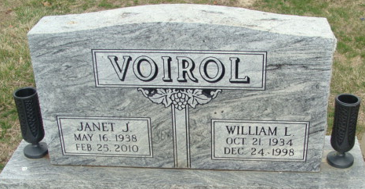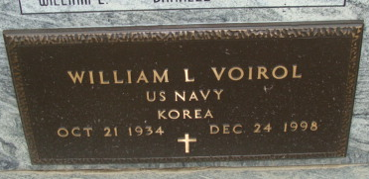
Photo by Alicia Kneuss

William L Voirol
in the Indiana, U.S., Death Certificates, 1899-2017
Name William L Voirol
Gender Male
Race White
Marital Status Married
Age 64
Birth Date 21 Oct 1934
Birth Place Monroeville, Indiana
Death Date 24 Dec 1998
Death Place Decatur, Adams, Indiana, USA
Death Registration Date 1998
Father John Voirol
Mother Myrtle M. Gerardot
Spouse Janet Courtney
Informant Mrs. Janet Voirol; wife; Decatur, Indiana
Burial December 28, 1998; Decatur Cemetery; Decatur, Indiana

