Ronald Lee Voirol
September 5, 1960 – September 8, 1997

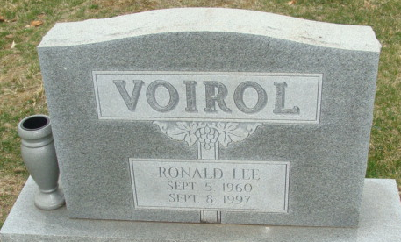
Photo by Alicia Kneuss

Ronald L. Voirol, 37, of Decatur died Monday at home. The Decatur native was employed at Decatur Casting Co.
Surviving are his wife, Laurel E.; a daughter, Lindsey A. at home; sons, Aaron S. and Matthew T., both at home; his parents, William and Janet Voirol of Decatur; sisters, Janalee Cole of Palmer, Alaska, Danalee Christener of Preble, and Holly L. Taylor of Orlando, Fla.; and his grandmothers, Margerite Courtney of Decatur and Myrtle Voirol of Fort Wayne.
Services are 2 p.m. Friday at Haggard & Armes Funeral Home. Calling is from 2 to 5 and 7 to 9 p.m. Thursday, with an 8:45 p.m. Moose memorial service. Burial will be in Decatur Cemetery.
Memorials are to Voirol Children's Education Fund.

News-Sentinel, Allen County, Indiana
September 10, 1997

**
Indiana, U.S., Death Certificates, 1899-2017
Name Ronald L. Voirol
Gender Male
Race White
Marital Status Married
Age 37
Birth Date 5 Sep 1960
Birth Place Decatur
Death Date 8 Sep 1997
Death Place Decatur, Adams, Indiana, USA
Death Registration Date 1997
Father William L. Voirol
Mother Janet Courtney
Spouse Laurel E. Hebble
Informant Laurel E. Voirol; wife; Decatur, Indiana
Burial September 12, 1997; Decatur Cemetery; Decatur, Indiana

