Janet J. (Courtney) Voirol
May 16, 1938 – February 25, 2010

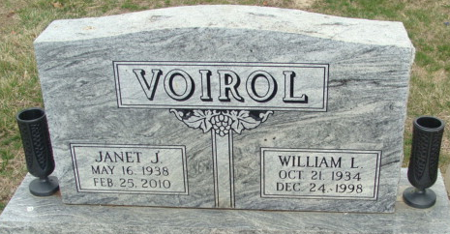
Photo by Alicia Kneuss

Janet J. Voirol, 71 years old of Decatur, Indiana, passed away on Thursday, February 25, 2010 at her residence. She was born on Monday, May 16, 1938 in Vevay, Indiana the daughter of the late Lyman Courtney and the late Marguerite A. (Wiley) Courtney. She married the late William "Bill" Voirol on January 21, 1956 in Angola, Indiana and he passed away on December 24, 1998. Janet was a former member of the Decatur Missionary Church. She was formerly employed by Duo Boat Factory in Decatur, Indiana and CTS in Berne, Indiana.
Surviving are her daughter, Janalee (Eric) Cole of Anchorage, Alaska, daughter, Danalee Voirol of Decatur, daughter, Holly L. Taylor of Cocoa Beach, Florida, brother, William "Bill" Courtney of Decatur, sister, Judy (Barry) Poling of Decatur, fourteen grandchildren, seventeen great-grandchildren and one great great-grandchild. Preceding Janet in death were three sons; Bill "Bug" Voirol Jr., Tony Voirol & Ronald Voirol and one granddaughter, Laura Moses.
Funeral services will be held at 10:30 a.m. Thursday, March 4, 2010 in the Zwick & Jahn Funeral Home with Rev. Floyd Vieth officiating. Interment will follow in the Decatur Cemetery. Friends will be received from 2:00 to 4:00 p.m. and 6:00 to 8:00 p.m., Wednesday, March 3 in the Zwick & Jahn Funeral Home, Decatur.
Preferred memorials are to the family.

Zwick & Jahn Funeral Home, Adams County, Indiana
February 26, 2010

