Danalee Voirol
June 4, 1962 – May 10, 2020

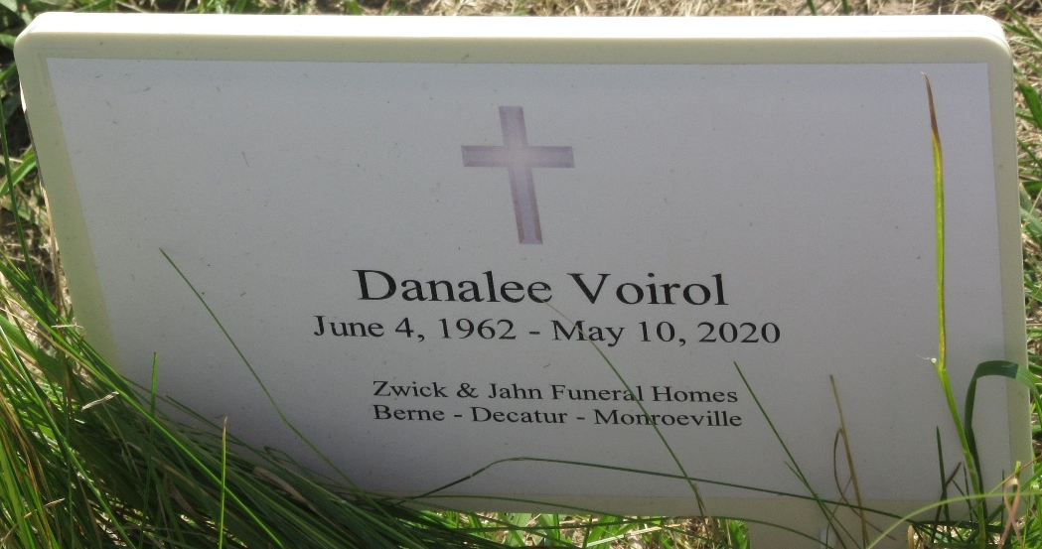
Photo by Barbara Baker Anderson

Danalee Voirol, 57, of Decatur, Indiana passed away Sunday afternoon, May 10, 2020, at her residence. She was born on June 4, 1962 in Decatur, Indiana to William “Bill” Voirol Sr. and Janet (Courtney) Voirol.
She received an associate’s degree in Culinary Arts and had worked as a dietary aid at Golden Meadows in Adams County.
She is survived by her daughter, Amy Moses of Decatur, Indiana; two sisters, Janalee (Eric) Cole of Anchorage, Alaska and Holly Taylor of Orlando, Florida; and seven grandchildren, Quinton, Veronica, Isiaha and Aaron Voirol and Rebekka, Roxanna, and Justuin Beitler.
She was preceded in death by her parents; daughter, Laura Moses in 2005; son, Ian Voirol in 2012; and three brothers, Bill “Bug” Jr., Tony, and Ronald Voirol.
Private graveside services will be held at Decatur Cemetery with Pastor James Voorman officiating. Preferred memorials are to Golden Meadows.

Zwick & Jahn Funeral Home, Adams County, Indiana
May 14, 2020

