Anthony Lee Voirol
November 27, 1963 – March 24, 1985

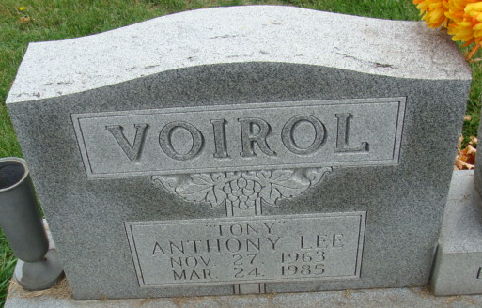
Photo by Alicia Kneuss

Anthony L Voirol
in the Indiana, Death Certificates, 1899-2011
Name: Anthony L Voirol
Gender: Male
Race: White
Age: 21
Marital Status: Married
Birth Date: 27 Nov 1963
Birth Place: Indiana
Death Date: 24 Mar 1985
Death Place: Decatur, Adams, Indiana, USA
Father: William J Voirol
Mother: Janet K Courtney
Spouse: Lisa K Poindexter
Informant: Lisa Voirol; wife
Burial: March 27, 1985; Decatur Cem.

