Myrtle Mina (Acker) Vizard
June 21, 1878 – November 1, 1941

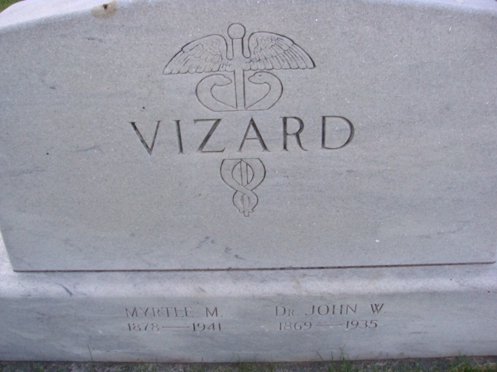
Photo by Alicia Kneuss

DEATH CLAIMS MRS. VIZARD
Mrs. Myrtle Vizard Dies This Morning after Long Illness

Mrs. Myrtle Mina Vizard, 63, prominent Adams County lady and widow of the late Dr. J. W. Vizard, of Pleasant Mills, died this morning at 1 o’clock at the Adams County Memorial Hospital. Death followed an illness of two months. She had been bedfast for the past two weeks. Her death was attributed to angina pectoris.
The deceased was born in Pleasant Mills June 21, 1878, the daughter of Norman and Loretta Carter-Acker. She had been a life-long resident of the village. Her husband, Dr. J. W. Vizard preceded her in death in 1935. She was a member of the Pleasant Mills Baptist Church.
Her parents came to the community from Columbus, Ohio in 1837 and were among the early settlers of the county.
Surviving are four children; Paris D. Vizard of Galesburg, Illinois; Mrs. Ruth Hyland of Indianapolis; Gordon A. Vizard of Los Angeles and Gerald W. Vizard of Decatur; a sister, Mrs. Ann Bartling of Los Angeles; two brothers, Alpheus Acker and Austin Acker of Pleasant Mills; and five grandchildren. Burial will take place in the Decatur Cemetery.

Adams County, Indiana Historical Museum
1941b January - December Scrapbook, image 131
Handwritten date: November 1, 1941

