Mabel I. (Hocker) Vizard
August 25, 1915 – March 9, 1994

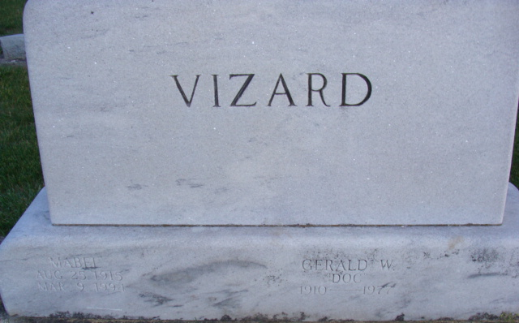
Photo by Alicia Kneuss

Mabel I. “Pudge” Vizard, 78, of Decatur died Wednesday in Adams County Memorial Hospital. The Adams County native was the owner of Tuck-A-Hoe Inn, Decatur, from 1955 to 1959, and the widow of Gerald "Doc," who died in 1977.
Surviving are her daughter, Marilyn Gehrig of Bluffton; a son, Larry K. of San Bernardino, Calif.; a brother, Kermit O. Hocker of Grass Lake, Mich.; four grandchildren; and seven great-grandchildren.
Services are 4 p.m. tomorrow in Haggard & Armes Funeral Home, Decatur, where calling is from 6 to 8 p.m. today. Burial will be in Decatur Cemetery.
Preferred memorials are gifts to Pleasant Mills Alumni Association.

News-Sentinel, Allen County, Indiana
March 11, 1994

**
Indiana, U.S., Death Certificates, 1899-2017
Name Mabel I Vizard
[Mabel I Hocker]
Gender Female
Race White
Marital Status Widowed
Age 78
Birth Date 25 Aug 1915
Birth Place Monroe, Indiana
Death Date 9 Mar 1994
Death Place Decatur, Adams, Indiana, USA
Death Registration Date 1994
Father Otis O Hocker
Mother Belle Burkhead
Informant Marilyn Gehrig; daughter; Bluffton, Indiana
Burial March 12, 1994; Decatur Cemetery; Decatur, Indiana

