Dr. John W. Vizard
November 10, 1869 – February 26, 1935

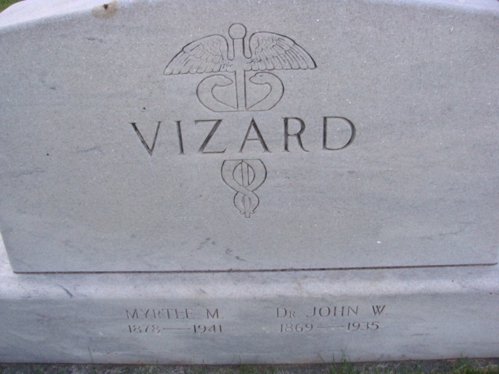
Photo by Alicia Kneuss

DOCTOR VIZARD FOUND DEAD
Dr. John Vizard, 65, Of Pleasant Mills, Dies Tuesday
DECATUR, February 28 – Dr. John Vizard, 65, one of Adams County's most prominent physicians, was found dead in bed at his home in Pleasant Mills at 8 o'clock Tuesday morning. Coroner Robert Zwick pronounced the cause of death as angina pectoris. He had recently suffered a severe attack of influenza but had visited in Decatur Monday.
When the doctor failed to arise at his usual hour Tuesday (cut off)

Adams County Historical Museum, Adams County, Indiana
1935 Scrapbook, image 5
Handwritten date: 1935
**
Indiana, Death Certificates, 1899-2011
Name: John W Vizard
Gender: Male
Race: White
Age: 63
Marital Status: Married
Birth Date: 10 Nov 1869
Birth Place: Ind
Death Date: 26 Feb 1935
Death Place: Pleasant Acres, Adams, Indiana, USA
Father: William Vizard
Mother: Ellen Rutledge ?
Informant: Mrs. J. W. Vizard, Pleasant Mills, IN
Burial: March 1, 1935 Decatur Cem.

**
HON. JOHN W. VIZARD, M. D.
The name of the Hon. John W. Vizard is held in high esteem in Adams County, both as a practicing physician who has gained the confidence of his clients and as a legislator of marked ability, whose first consideration has been the interests of his constituency.
Dr. Vizard was born in Monroe township, Allen County, November 10, 1869. He is a son of William and Elizabeth (Ratledge) Vizard. His father was a farmer of Allen County and lived until his death on his farm. His death occurred in 1901, at the age of sixty-six and he had the distinction of living continuously on his farm for forty-five years. His mother was the daughter of Moses and Catherine Ratledge and was the second white child born in Monroe township. They had ten children, of whom Dr. Vizard was the fifth in order of birth.
Dr. Vizard was reared on his father's farm and received a preliminary education in the common schools of his neighborhood. Early in his school life he showed a peculiar aptitude for study and after finishing his early education he attended schools at Fort Wayne, the Middlepoint Normal School at Middlepoint, Ohio, and the Holbrook National Normal School at Lebanon, Ohio. It was while attending this latter institution that he decided to adopt medicine as his profession. Accordingly, after his classical course was completed, he matriculated in the medical department of the same school. He was a careful and earnest student and was graduated in medicine from the Lebanon school August 12, 1892. After he had graduated and was admitted to practice, he established himself in an office at Dixon, Ohio. He continued to practice his profession at Dixon for six months and then removed to Pleasant Mills, in Adams County, Indiana. He opened his office in Pleasant Mills in April, 1893. His career as a practicing physician has been a most successful one. He attracted a large patronage almost from the beginning of his practice, and this clientage has grown until it is one of the largest and most profitable in his community.
Politics have always held a live interest for Dr. Vizard. Soon after establishing himself in Pleasant Mills, he began to take an active part in the politics of his county. He is a Democrat and has taken an important part in the political struggles of his section of the state under the banner of this party. His efforts and work were rewarded in November, 1904, when he was elected to the state legislature on the Democratic ticket. He showed himself an able representative and took a leading part in the deliberations of the state's law-making body in the session of 1905. So well and satisfactorily did he do his work that he was re-elected to the legislature for the session of 1907. The records of that memorable and stormy session show that Dr. Vizard bore himself gallantly and that his voice and vote were ever to be found on the side of the measures that were for the people's interests, as opposed to the interests of corporations or "special interests." His service in the legislature was with distinction at both sessions and gave added reason for the high respect in which he is held.
On May 14, 1896, Dr. Vizard was married to Miss Myrtle M. Acker, a daughter of Norman and Loretta Acker. She was born in Adams County and was always a resident of Saint Mary's Township. Her parents were among the oldest settlers in the township. Three children have been born to Dr. and Mrs. Vizard. These children are: Paris D., Ruth M. and Gordon A. Mrs. Vizard is an active member of the Baptist Church.
As a physician Dr. Vizard ranks very high in his profession. He is a progressive and an aggressive man. He realizes that to be a successful physician means to keep abreast with the changes, developments and discoveries in his profession. This he does by careful reading and by keeping in close touch with the leaders of medical thought. His equipment is most admirable and he deserves the distinction he enjoys of being one of the best and most accomplished physicians of northeastern Indiana. He is a member of the Knights of Pythias Lodge, No. 65, at Decatur.

Snow's History of Adams County, Indiana, John Fletcher Snow, B. F. Bowen, Indianapolis, IN, 1907

