Gordon A. Vizard
December 29, 1901 – October 3, 1980

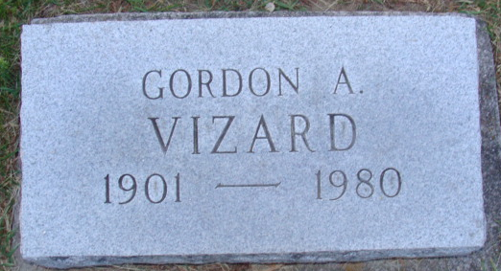
Photo by Alicia Kneuss

Gordon A. Vizard
in the Indiana, U.S., Death Certificates, 1899-2017
Name Gordon A. Vizard
Gender Male
Race White
Marital Status Divorced
Age 78
Birth Date 29 Dec 1901
Birth Place Indiana
Death Date 3 Oct 1980
Death Place Decatur, Adams, Indiana, USA
Death Registration Date 1980
Father John Vizard
Mother Myrtle Acker
Informant Mrs. Gerald Vizard; Decatur, Indiana
Burial October 6, 1980; Decatur Cemetery; Decatur, Indiana

