Gerald W. Vizard
March 29, 1910 – July 22, 1977

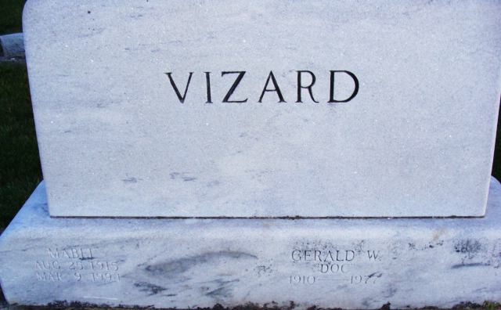
Photo by Alicia Kneuss

Gerald W. Vizard
in the Indiana, U.S., Death Certificates, 1899-2017
Name Gerald W. Vizard
Race White
Marital Status Married
Age 67
Birth Date 29 Mar 1910
Birth Place Indiana
Death Date 22 Jul 1977
Death Place E Decatir, Adams, Indiana, USA
Death Registration Date 1977
Father J. W. Vizard
Mother Myrtle Acker
Spouse Mabel I. Hocker
Informant Mrs. G. W. Vizard; wife; Decatur, Indiana
Burial July 25, 1977; Decatur Cemetery; Decatur, Indiana

