Rev. Nathaniel Edward Vitz
November 16, 1878 – January 27, 1951

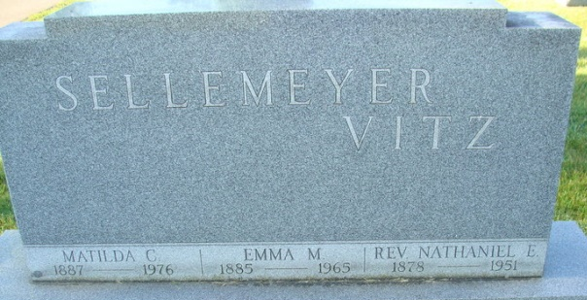
Photo by Alicia Kneuss

Rev. N. E. Vitz

St. Mary’s, Jan. 30 – Services were held Monday afternoon in Payne for the Rev. N. E. Vitz, 70, retired minister of the Evangelical and Reformed church, who died Saturday at his home in Payne. He was an uncle of Miss Emma Kohler, A. J. Kohler and Mrs. Carl Steva of St. Marys.
Mr. Vitz was one of five brothers who entered the ministry of the Evangelical and Reformed church. All five are deceased. He was pastor of the Zion church in New Bremen for about 20 years before going to Payne about 1942. Two years ago he retired.

Lima News, Allen County, Indiana
Tuesday, January 30, 1951
**

Rev. Vitz Buried at Decatur, Ind.

Headed by Rev. L. G. Fritz, a group of Zion Church members attended the funeral services conducted Monday at Payne, Ohio for Rev. N. E. Vitz, former pastor of the church here. Included in the group were Rev. and Mrs. L. G. Fritz, Miss Vesta Fritz, Mrs. W. A. Havemann, Mrs. Martha Huenke, Miss Frieda Dierker, Mrs. Harry Komminsk, Mr. and Mrs. Paul Gilberg, Mrs. Hilda Burk, Mr. and Mrs. Leo Strasburg, Mrs. Adolph Koenig, and Ben Hirschfeld.
Rev. Vitz was pastor of the New Bremen Church from February, 1922 to August 1944. During his long pastorate here he accomplished much of lasting well within the church and congregation.
He was one of 10 children of Rev. and Mrs. Peter Vitz. There were seven sons, five of whom eventually became ministers.
Surviving Rev. Vitz are the widow, Mrs. Emma Vitz, two sons, Rev. Robert Vitz, a U.S. Marine Corps chaplain, Rev. Richard Vitz, Germantown, Pa.; two daughters, Mrs. Albert (Dorothea) Schroer, Pennsylvania and Mrs. Arden (Betty) King, Payne.
There are two sisters living, Mrs. Henry Roblock, Defiance and Mrs. Anna Eberhardt, Indianapolis, Ind.

N.B. Sun
February 1, 1951
**
Ohio Deaths
Name Nathaniel Edward Vitz
Event Type Death
Event Date 27 Jan 1951
Gender Male
Age 72
Race White
Birth Date 16 Nov 1878
Birthplace Vera Cruz, Indiana
Birth Year (Estimated) 1879
Father's Name Peter Vitz
Mother's Name Anna Marie Jacobs

