Emma M. (Sellemeyer) Vitz
June 27, 1885 – February 5, 1965

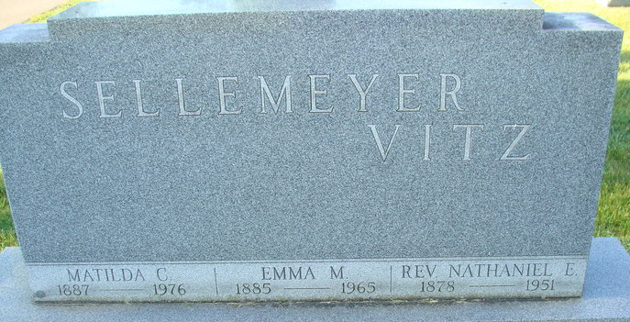
Photo by Alicia Kneuss

Emma Vitz Payne

Mrs. Emma Vitz, 79, died Friday in Columbia Nursing Home, Lima, where she had been in failing health a year. A native of Decatur, Ind., she was born June 27, 1885, a daughter of Herman and Syvilla (Kohler) Sellemeyer. Mrs. Vitz was a member of St. Jacobs United Church of Christ, Women's Guild, and Twentieth Century Club. She was the widow of Rev. Edward Vitz.
Survivors include two sons, Chaplin Robert H. of the U.S. Navy and Rev. Richard P. of Lima; two daughters, Mrs. Dorthea Scheoer and Mrs. Betty King, both of Defiance; three sisters, Miss Matilda Sellemeyer, Mrs. Agunus Yager and Mrs. Hulda Poling, all of Decatur and 10 grandchildren.
Services will be at 2 p.m. Monday in St. Jacobs United Church of Christ, Rev. H. A. Meussling officiating. Burial will be in Decatur, Ind. Friends may call anytime at Slade Funeral Home, Payne.

Lima News, Van Wert County, Ohio
February 7, 1965

