Maximilian Virgil
January 6, 1902 – April 1, 1997

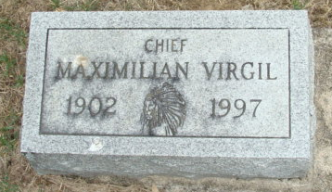
Photo by Alicia Kneuss

Maximilian Virgil, 95, of Decatur died Tuesday in Adams County Memorial Hospital. The Socorro, N.M., native was a former schoolteacher and widower of Mary A., who died in 1987. He was a member of the Isleta Anasazi Indian tribe.
Surviving are a daughter, Lupe Smith of Culver City, Calif.; a son, Max of Los Angeles; a brother, Severo of Albuquerque, N.M.; and six grandchildren.
Services are 2 p.m. Saturday in Haggard & Armes Funeral Home, Decatur, where calling is noon to 2 p.m. Saturday. Burial will be in Decatur Cemetery.

News-Sentinel, Allen County, Indiana
April 3, 1997

**
(Beginning missing)

... Virgil was a member of the Isleta Anasazi Indian Tribe and a member of United Pentecostal Church.
He was born on January 6, 1902, in Socorro, New Mexico, the son of Frank and Antonia Armijo Virgil. He was married to Mary Ann Virgil on October 25, 1952; she died on February 15, 1987.
Survivors include a son, Max Virgil, Los Angeles; a daughter, Lupe Smith, Culver City, California; a brother, Severo Virgil, Albuquerque, New Mexico; and six grandchildren.
Services will be held at 2 p.m. Saturday in Haggard and Armes Funeral Home, Decatur, and burial will follow in Decatur Cemetery. Calling will be from noon until 2 p.m. Saturday.

Decatur Daily Democrat; Adams County, Indiana
Wednesday, April 2, 1997
**
Indiana, Death Certificates, 1899-2011
Name: Maximillian Virgil
Gender: Male
Race: White
Age: 95
Marital Status: Widowed
Birth Date: 6 Jan 1902
Birth Place: Socorro, New Mexico
Death Date: 1 Apr 1997
Death Place: Decatur, Adams, Indiana, USA
Father: Frank Virgil
Mother: Antonia Armijo
Informant: David Haggard, friend, Decatur, Ind.
Burial: April 5, 1997 Decatur Cem., Decatur, Ind.

